Tips and Tricks for Days Indoors
- MAINTAINING A SCHEDULE WHILE CHILDREN ARE AT HOME IS KEY!
  - Keeping children on their normal schedule when at school or daycare is key to easy transitioning when it is time to go back.
  - Sample Schedule for Toddler and Preschool Age
    - Breakfast (7:00 AM – 9:00 AM)
      - Provide options like what they would eat at daycare
        - Cereal and milk
        - Waffles
        - Pancakes
        - Grits
        - Fruit
        - Milk or water to drink
    - Morning Activity 1 (9:00 AM-10:30 AM)
    - Morning Snack (10:00 AM – 11:00 AM)
      - This is optional and depends on the time they eat breakfast!
        - Fruit
        - Crackers
    - Lunch (11:30 AM – 12:30 PM)
      - Sandwich/chips
      - Noodles
      - Leftovers of your choosing
    - Activity 2
    - Activity 3
    - Afternoon Snack (4:00 PM)
      - Chips
      - Crackers
      - Cookies
      - Fruit
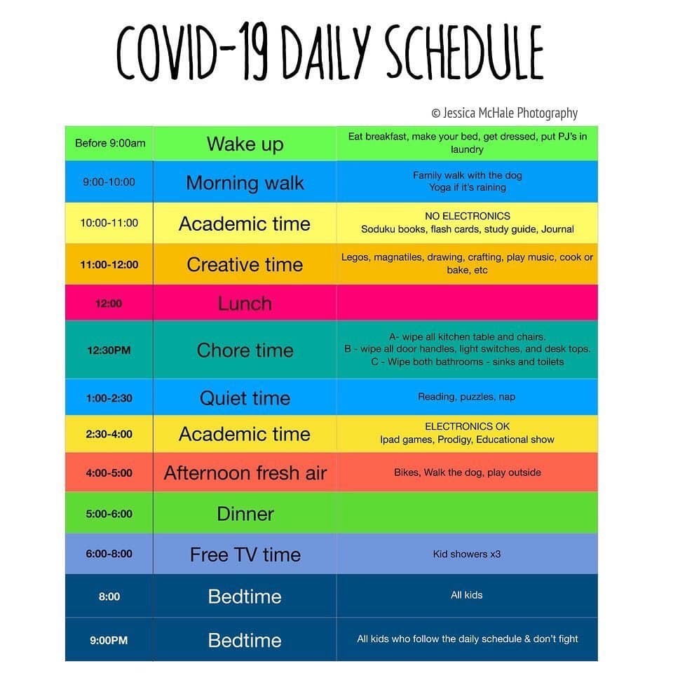
  - Sample Schedule for School Age

Age Appropriate Activities
- Toddlers
        - Construction paper shapes
          - Instructions: Cut out different shapes and colors to help with cognitive development.
          - Cut out 2 of each shape and create a matching game.
        - Index cards with letters and shapes
          - Use different color markers to double the learning potential!
        - Ball activities
          - Rolling or catch
          - Set up a laundry hamper to serve as a hoop
  - Coloring
    - This can be entertainment for child and a relaxing activity for parents. Also, this allows you to spend quality time together and make something to keep.
  - Youtube: Cocomelon
    - School Age
      - Numbers and Reading
        - Different colors around the home
        - “I Spy” around the house
      - Cup staking
        - Instructions: use plastic cups to stack in a pyramid shape and restack them on top of each other. Helps with cognitive and gross motor functions.
      - Toy Sorting
        - Have them dump out all the toys and sort them according to color and toy.
    - Teenager
      - Complete any schoolwork that was assigned.
      - Closet Cleanout
      - Future planning
        - College/Trade research
        - Make a dream board or vision board
Resources for Mom
- NA 24hr Hotline: (866)523-1421
- Free Counseling Hotline: 855-264-7704
  - Text CONNECT to 741741

